Geologic Computing HW6
Steven Rizo

Problem 1:
Visualize earthquake magnitude data by creating a location map, plotting the locations of the earthquake hypocenters, and using the symbols to visualize the depth and/or magnitude of the hypocenters.
Plotting the earthquakes with point size = magnitude creates individual symbols that cover most of the map, so the size must be reduced. In addition to this, the magnitude values are logarithmic, so a linear relation ship of point size shows little relative information for the magnitudes,To scale the magnitudes for plotting and make the relative magnitudes more apparent, point size = (magnitude^3) / 600.

Flow Chart:
This flow chart applies to plot 2, but the same steps are followed for plot 1 with the exception of removing the color scaling steps.
Begin
Input .csv earthquake magnitude data
Sort the data file from highest to lowest magnitude
For each line of data
Scale point size for earthquake magnitude
$mag_scale = ($mag ** 3) / 600
Print line of output data with:
longitude latitude depth mag_scale
More data?
Eliminate depth column for plot 1
True
False
Output .dat file of earthquake magnitude and/or depth

Step 1:
End
Create formatted data file
Usage
Plot 1: perl csv_scale.pl north_cal.csv > cal_scale.dat
Plot 2: perl csv_color.pl north_cal.csv > cal_color.dat
Step 2:
Begin
Create map
Input formatted .dat earthquake magnitude data
Create a depth.cpt color scale for psxy plotting using makecpt
The color scale should be based on the range of depths in the data
Create greyscale location map using pscoast
Plot hypocenter data on location map using psxy with circular symbols
Symbol size should be based on the scales magnitudes from the input file
Color Fill for circles based on the depth.cpt
Remove for Plot 1
Use -G single color fill for Plot 1
Add colorbar to location map for depth.cpt
Output final .eps file for location map with added data
Convert .eps file to .png and output new file
End
Remove for Plot 1
Usage
Plot 1: perl quake_scale_mag.pl
Plot 2: perl quake_color_mag.pl
Figures:
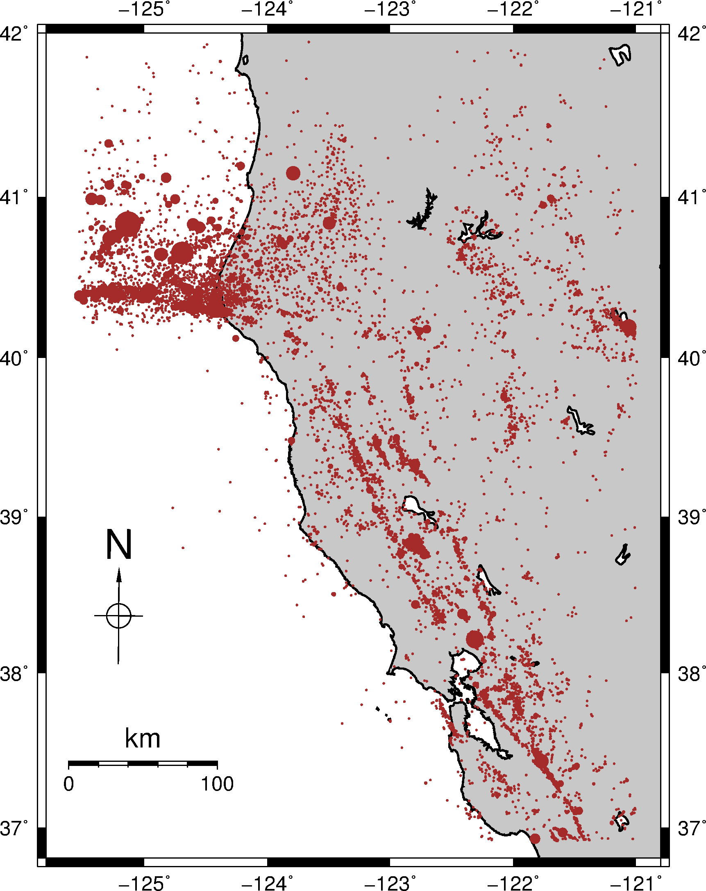
Plot 1: Plot of earthquake hypocenters along the Pacific coast in Northern California as red circles. The size of the circles is based on the magnitude of the hypocenter with larger circles correlating to higher magnitudes.
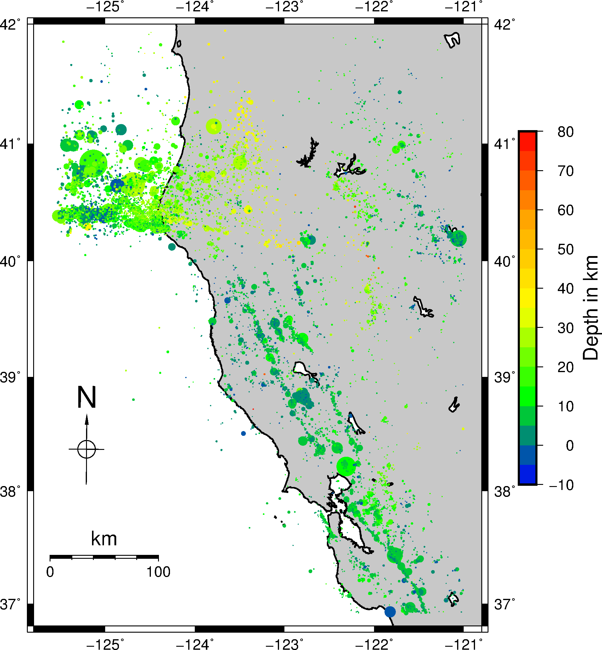
Plot 2: Plot of earthquake hypocenters along the Pacific coast in Northern California. The size of the circles is based on the magnitude of the hypocenter with larger circles correlating to higher magnitudes. The color of the circles is based on the depth of the hypocenter, and the correlated depths and collors can be seen on the color bar to the right of the location map.
Problem 2:
contour the elevation on the Crater Lake area including the elevations outside of the crater by converting the filtered data into a grid file and creating a contour map using grdcontour with an included color bar.

